**Global Super Store Analysis Report**

# Table of Contents

1. Executive Summary
2. Introduction
3. Global Market Performance
4. United States Market Performance
5. United States Profit Analysis
6. United States Shipping Analysis
7. United States Customer Behavior
8. Conclusion

# Executive Summary

The main goal of this study was to examine how the Global Superstore is doing in the market globally, with the main focus on the performance of the United States. The United States is the biggest contributor, making up almost one-fifth of the whole global market in sales and profits. This report is mainly about looking into different parts of the US market, like where they sell products and make money, what kind of products they have, how they move things around, and who their customers are. The main idea of this report is to give useful ideas and suggestions. These ideas are supposed to be a good resource for the top managers, helping them to make smart business plans and improve how they make decisions.

# Introduction

This analysis utilizes the data from 2016 to 2020, with the goal of finding valuable insights that matter for business. To reach this goal, we'll start by looking at how the whole market is doing. Then, we'll look closely at how certain things affect the overall profit. The main point of this project is to find out which part of the market makes the most money, check how much money there is, how people behave, and how things are shipped. This analysis wants to find out the potential of the market and see where things can get better. Also, we'll forecast how much money can be made in the future under some assumptions.

# Global Market Performance

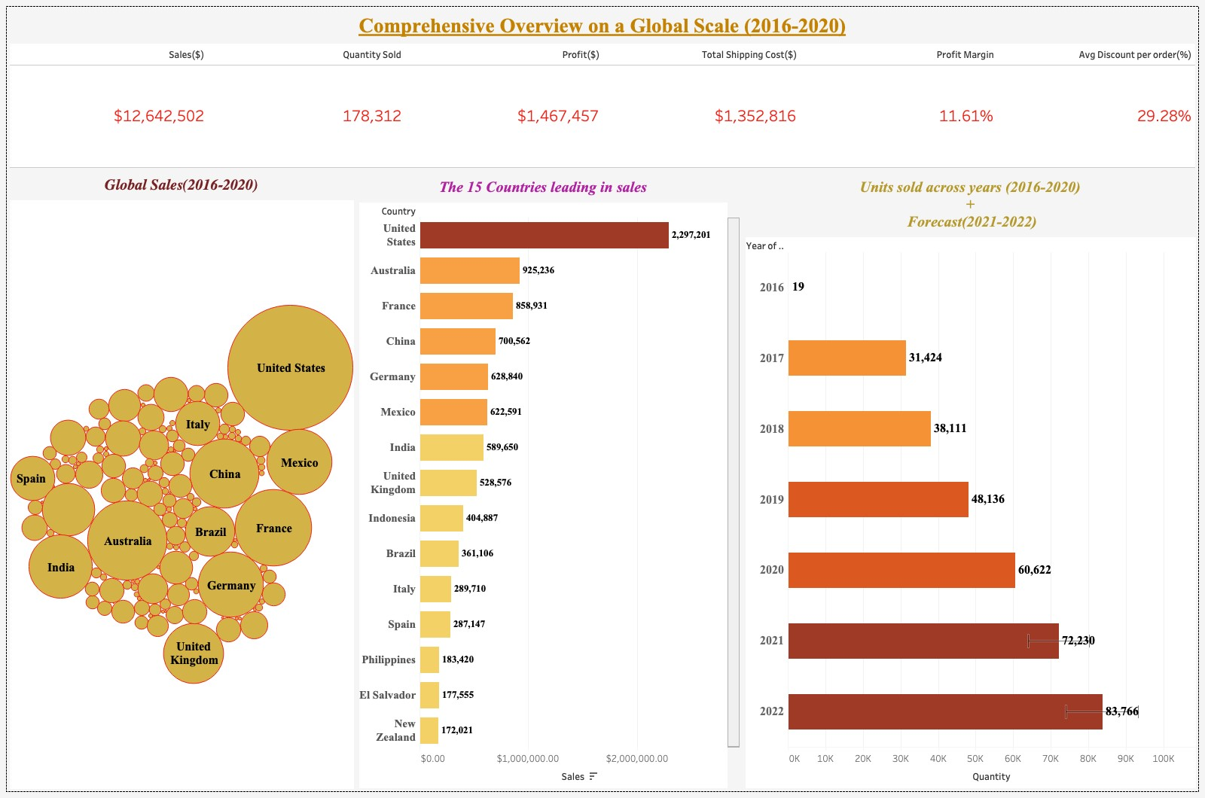

Figure 1: Overview on a global scale

From 2016 to 2020 the Global Superstore has made a total revenue of $12,642,502. The United States, Australia, and France are the countries that bring in the highest revenue.

The third bar plot in Figure 1 shows an increasing demand in sales over the years which clearly indicates the growing popularity of this store. In these five years, it sold a total of 178,312 items. In 2016 it only sold 19 items, but in 2020, it sold a vast 60,622 items. If this trend continues, the expected number of items sold for the next two years, 2021 and 2022 will be 72,230 and 83,766 as shown in Figure 1, respectively.

In these five years, the store has spent a total of $1,352,816 for shipping and has given an average discount of 29.28% per order. Resulting in $1,467,457 of profit generated.

As shown in the first and second diagrams in Figure 1, the United States has brought a revenue of $2,297,201 which is more than the amount combined in Australia and France ($1,784,167). This indicates the importance of analyzing the US market. Due to this reason, the rest of the report will be narrowed with a focus on the US market.

# United States Market Performance

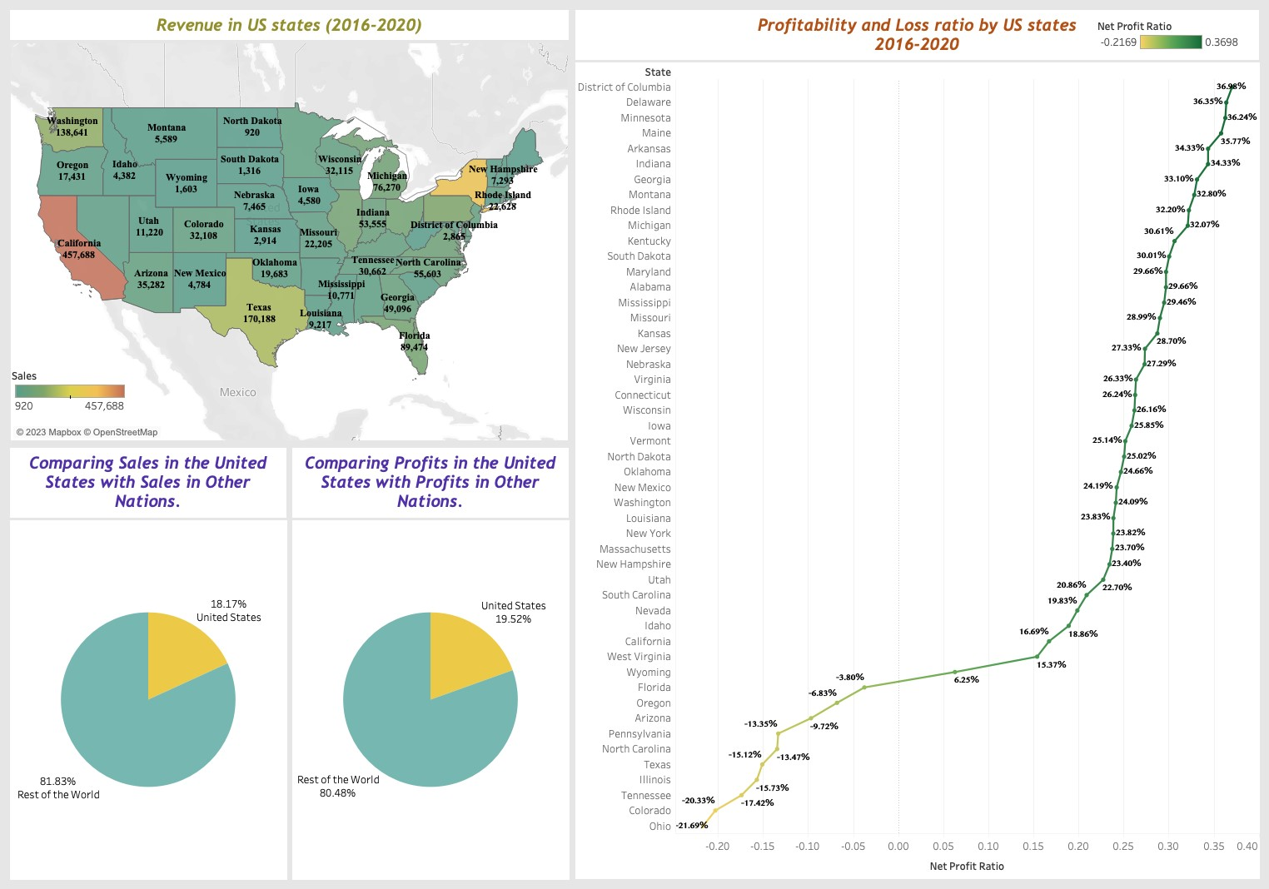

Figure 2: Revenue, Profitability, and Loss ratio by US states

Of the 147 countries where the store does its business, the United States has a noteworthy role, making up 18.17% of the total global sales revenue and 19.52% of the global profits. As shown in Figure 2, California, New York, and Texas states take first, second, and third places in revenue in the USA, respectively. North Dakota, West Virginia, and Maine report the lowest sales revenue in these years. While sales revenue by state alone does not provide complete information on the performance of the store, it provides some basic understanding of the distribution of the customers in the USA. A clear conclusion that can be drawn from these numbers is that the states with high populations tend to do better in terms of sales, while those with low populations have lower sales numbers. This must be analyzed to understand the relative performance by state which might provide information on potential improvement in sales. For example, a state with a lot of people like Florida (it's the third most populated state in the US) might still have more potential for increasing sales.

In terms of the profit ratio, the District of Columbia, Delaware, and Minnesota are the best-performing states, while Ohio, Colorado, and Tennessee have significant losses. The next section is dedicated to analyzing the distribution of profits in more detail.

# United States Profits Analysis

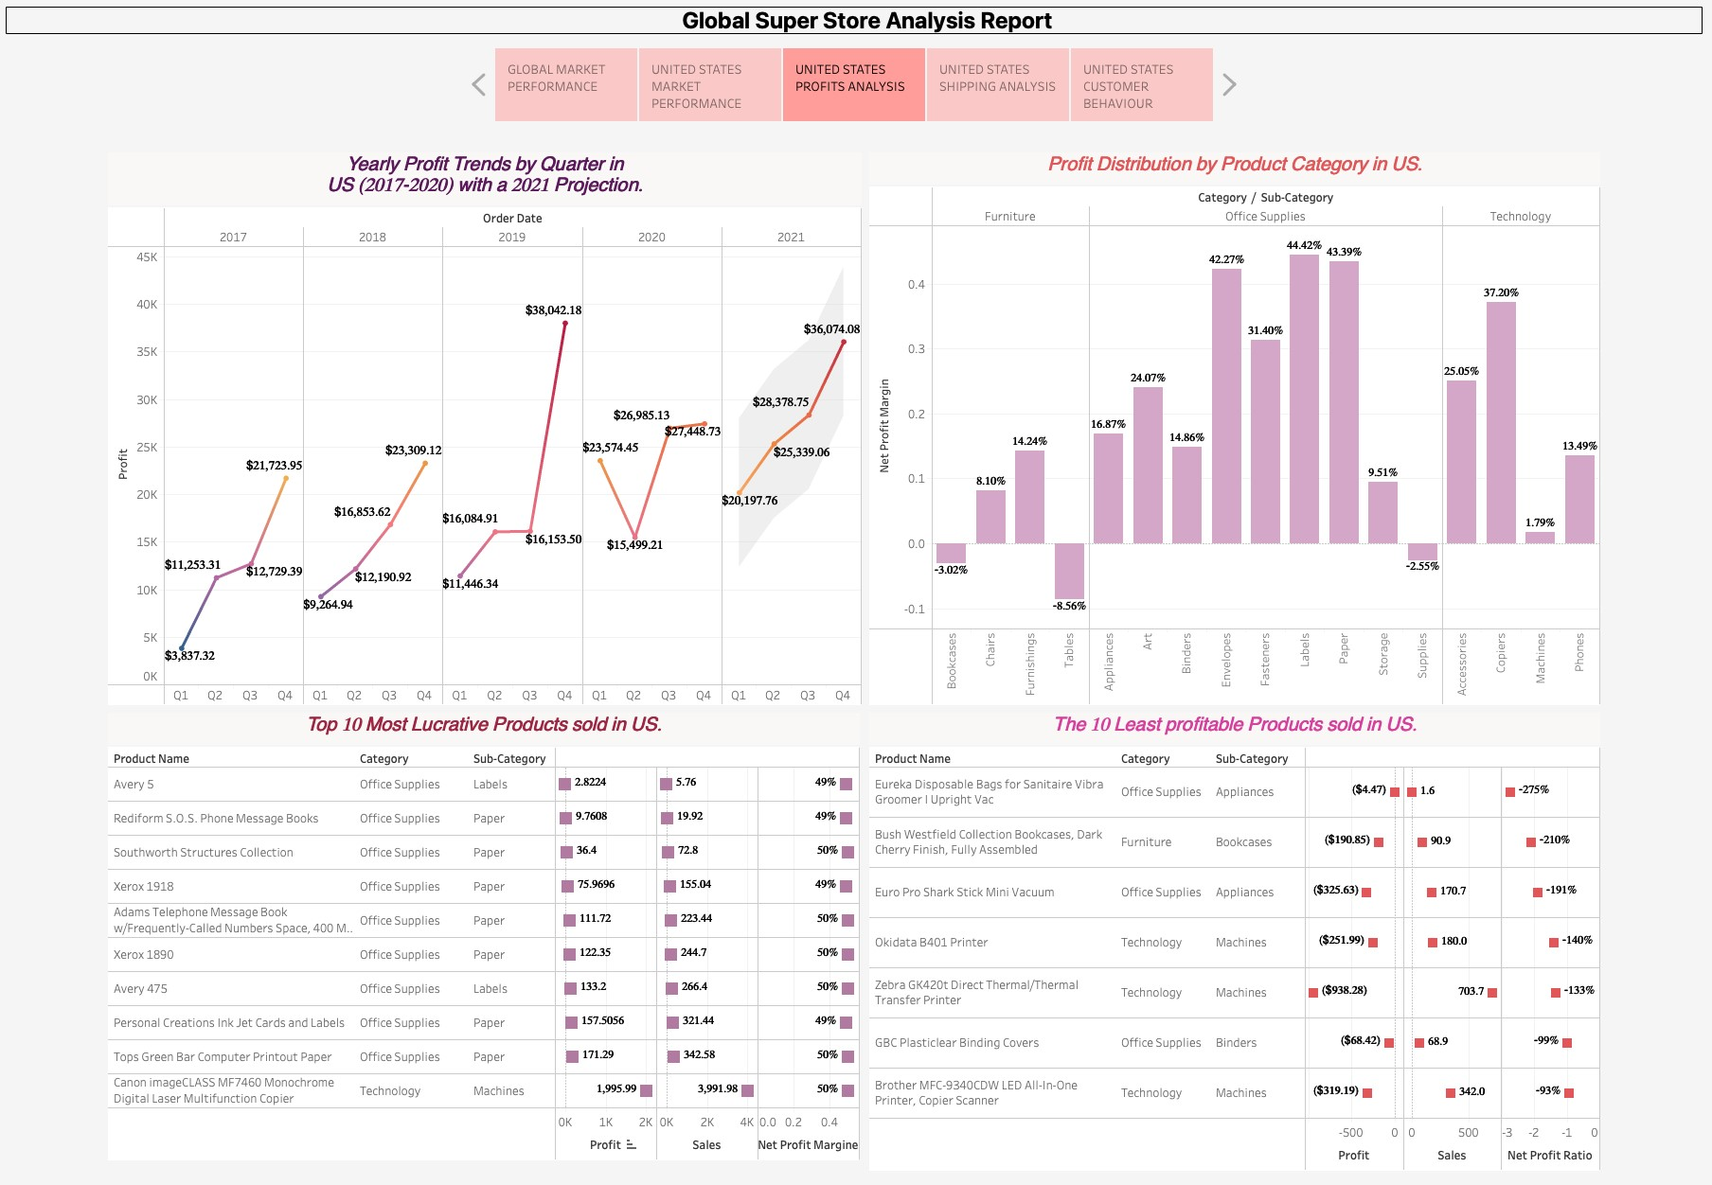

Figure 3: Distribution of profits

As shown in the top left panel of Figure 3, during the period of 5 years there is a consistent pattern in the quarterly sales. Every year, the profits for each quarter tend to follow a similar path, with the lowest profits happening in the first quarter (Q1) and the highest in the fourth (Q4). This increase in profits in Q4 is rational because of Black Friday deals and discounts during the holiday season, which make people spend more. The only time this pattern changed was in 2020 when the profits in Q2 ($15,499) were less than in Q1 ($23,574). This decrease was because of the COVID-19 pandemic, which was at its worst from April to June and damaged supply chains all over the world. But, the profits started going up again for the rest of 2020, showing that the company adjusted and kept going despite the pandemic. Looking at these past trends, the forecast for 2021 suggests that the usual pattern will continue, even though it might not beat the highest profit from Q4 in 2019.

When considering net profit margins for different product categories, it's clear that office supplies, especially things like labels (44.42% profit margin), papers (43.39% profit margin), and envelopes (42.27% profit margin), were the most profitable during this time. Interestingly, none of the technology items made a loss during this period. On the other hand, the furniture category, especially tables, was always sold at a loss (-8.56% profit margin). The least profitable item sold during this time was the "Eureka Disposable Bags for Sanitaire Vibra Groomer," which had a big loss in profit margin, at 275%. It's a good idea for the senior management to think about finding better options or maybe stopping items that have consistently made big losses in profit margins during this time.

# United States Shipping Analysis

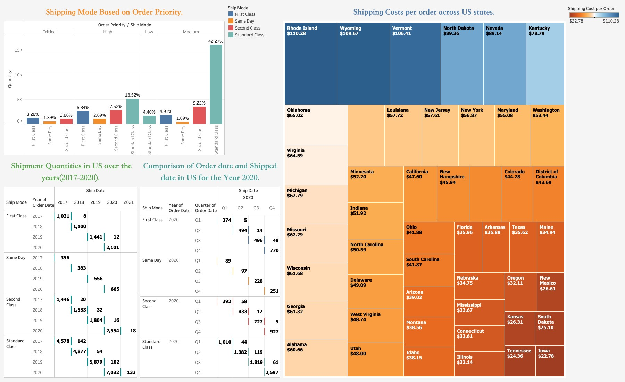

Figure 4: Shipping cost analysis

When considering customers' choice of shipping methods, it's interesting to see that most of them go for the more affordable Standard Class (S.C) shipping, even if their order is not very urgent, like the Low (4.40%) or Medium (42.27%) priority ones. Surprisingly, even for high-priority orders, people still pick Standard Class over Same Day or First-Class options. One possible reason for this might be that people think Same Day and First-Class are more expensive, so they choose the cheaper Standard Class, even for important orders. So, it might be a good idea to think about changing the prices to attract customers with high-priority and time-sensitive orders to the more expensive shipping options.

When focusing on the costs to ship to each state in the United States, Rhode Island, Wyoming, and Vermont seem to be the most expensive states, with costs of $110.28, $109.67, and $106.41, respectively. So, it's a good idea to try and find cheaper ways to ship to these states.

Looking at how many items were shipped over the years, there exists a clear pattern across all the different shipping options. The number of items sent has risen every year, and 2020 was the year with the most items shipped. This also confirms the increase in revenue analyzed in section 3.

To analyze the efficiency in processing orders, we measure the time taken from the order date to the shipping date. In 2020, in First Class shipping, many orders placed were shipped in the following quarter. For example, 48 items ordered in Q3 2020 were sent in Q4, showing that there might be a delay in shipping. Generally, the First Class method is believed to be the best way to ship; it's a good idea to work on reducing the time it takes to ship these orders after they're placed.

# United States Customer Behaviour

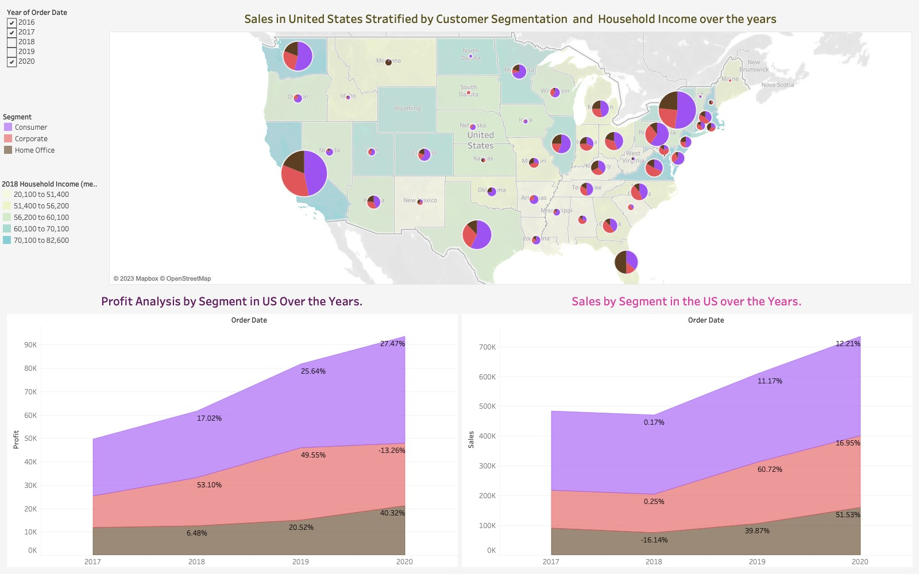

Figure 5: Customer behavior analysis

Looking at the data about customer groups from 2016 to 2020, we can see a clear pattern in states where people have more money in their households, they tend to spend more on consumer items, while in states where household incomes are lower, people prefer to buy corporate items. For example, in California and New York, most of the customers are in the group that buys things for themselves, but in South Dakota and Maine, most customers are in the group that buys things for their work.

When checking the profits and sales for the different customer groups from 2017 to 2020, all three groups, Consumer, Corporate, and Home Office, grew year after year. The only time this didn't happen was in 2019 when profits for the Corporate group went down by 13.26%. So, the biggest growth in profits and sales happened in the Home Office group in 2020. In that year, this group's profits went up by a big 40.32%, and their sales increased by an impressive 51.53% compared to the year before.

# Conclusion

To summarize, the United States shines as one of the most important global markets for the Super Store. The store expects continued growth in both sales and profits in the upcoming years, even during a worldwide pandemic. However, to perform well in this highly competitive business environment, various recommendations arise from the analysis:

1. Give Priority to States with Larger Populations: As the analysis suggests, states with more people tend to generate higher sales. It's essential to pay extra attention to states with substantial populations that have, nevertheless, produced relatively lower sales revenue. Targeting these markets could offer significant growth opportunities.
2. Deal with Unprofitable Products: Over the course of five years, certain products have consistently been sold at a loss. This report has pointed out specific items falling into this category. For such products, it's advisable to either find more profitable alternatives or think about discontinuing their sale altogether.
3. Optimize Shipping Costs: In certain states, the cost of shipping per order is notably high, as indicated in the report. Exploring alternative shipping methods can help reduce costs and, ultimately, enhance overall profitability in these states.
4. Improve Order Processing for Premium Shipping: Efforts should be made to enhance the efficiency of order processing for premium shipping modes, such as First Class. Additionally, reconsidering pricing structures for these premium modes can ensure that customers receive optimal service for their specific needs.

By putting these recommendations into practice, the Super Store can position itself for ongoing success and growth in the ever-changing and competitive market landscape.

